General Information
Team name → Seaside Games
Team members →
Nunzio Arcifa (921559)
Matteo Dell’Oro (910238)
Alfio Giuliano Faro (908958)
Chen Qixuan (10592030)
Maura Saccà (894850)
__________________________________

Constraints
Cards → Gnome in the Mountains & Pirates in the Tavern. We’re using both: the gnome is the merchant, the only inhabitant of the World Between, and the gambling side of the tavern is implemented in the random item, purchasable from the very same gnome.
Game Genre → Action: Shooter & Action: Fast Puzzle. We’re using only the first one.
Time → Future
Player mindset → Midcore
Bartle’s type → Socializer
Mode → Multiplayer
__________________________________
Part 1 - Concept
Concept → Y.O.L.T. (You Only Live Twice)
Logline → Fight to the last man, but don't be afraid to take one for the team, as dying is just the beginning.
Introduction↴
The order between the worlds of the living and the dead is broken. For thousands of years Gatekeepers had always protected the Portals between these realms, the World Between, but when in the Life World some explorers found and use an ancient artefact without knowing its true power, the resurrection of the death, they got angry and decided to abandon their duties to punish them. They left the Portals unprotected destroying the balance between those two dimensions.
Some brave soldier were sent in the World Between, where they need to fight the dead coming from the Dead World in order to restore the balance.
Game Description↴
Play as one of the brave men and join your teammates in order to destroy the creatures that live in the world between, in a survival shooter game. The enemies come in waves, and cooperation with the other player is key in order to get rid of them. After the players reach the necessary number of resources they can decide to expand the gameplay area in order to have more space and tools, which can be bought from Yaff the Gnome, to keep the adventure going.
Key Features↴
Look out for your friends while you are alive and even more when you die. Once a player dies he becomes a “ghost” and, after having collected enough resource, he can link his movement to the one of an ally player who is still alive, by becoming a sort of addon of that character.
Platforms↴
PC, PS4, XBOX1. No mobile platforms as the game mechanics make the gameplay too difficult on a handheld device. Console were considered as the “plug-and-play” style of the game, with fast matches, is suitable to be played on those.
Concept Art↴
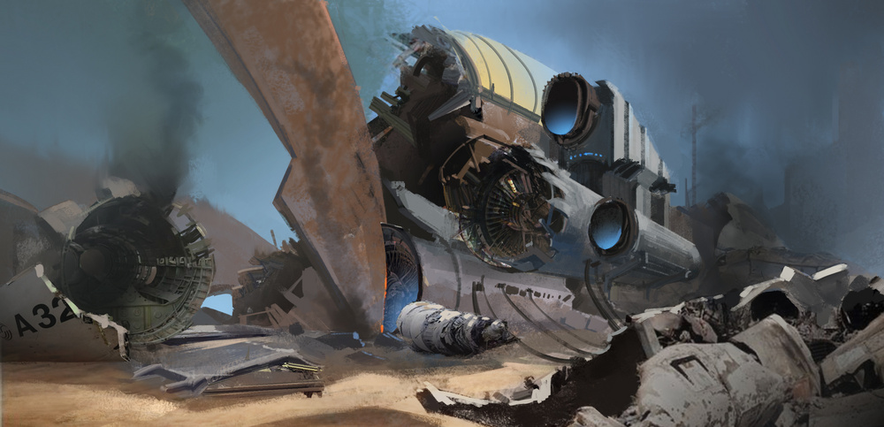
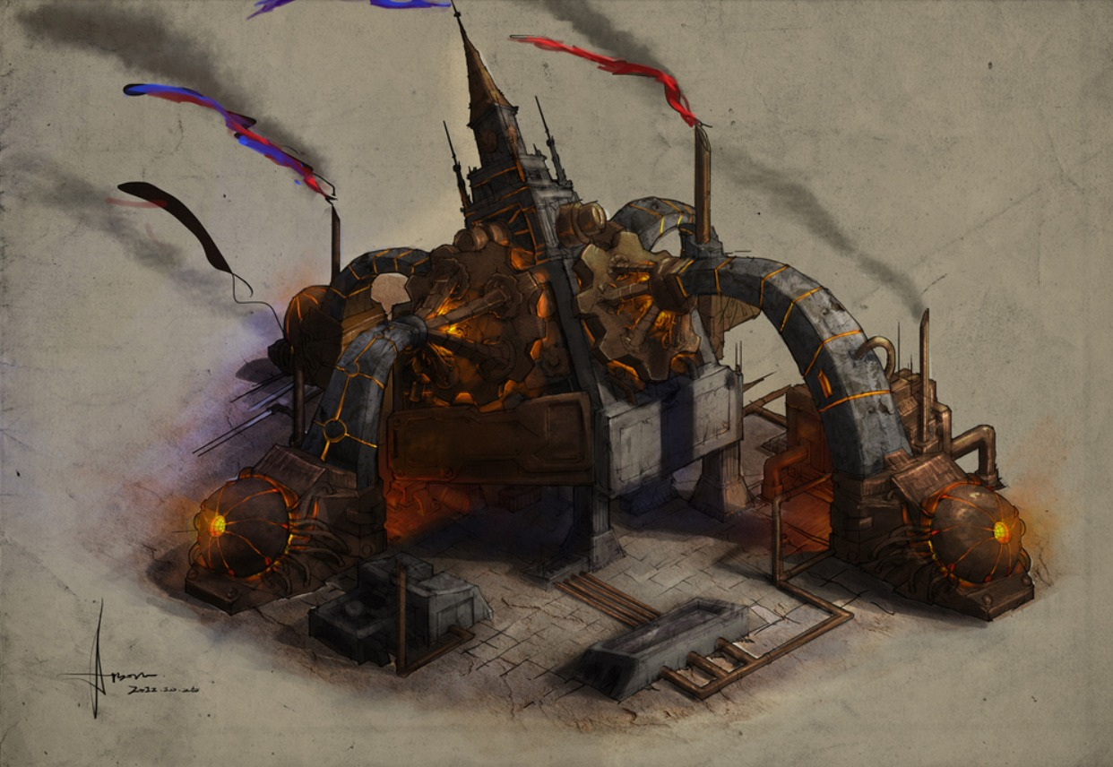

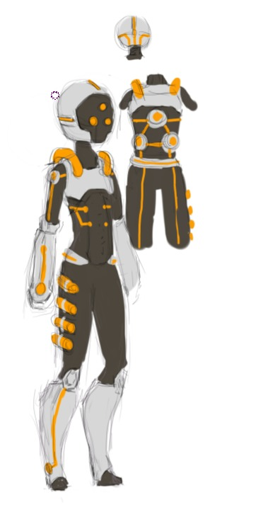

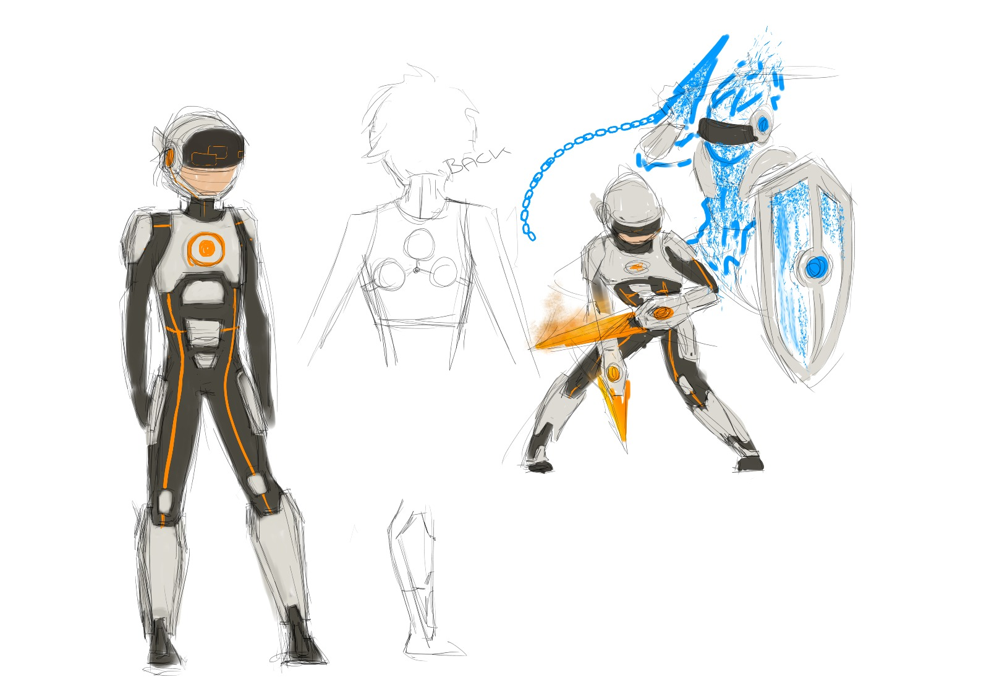

Part 2 - Formal & Dramatic Elements

Formal elements

1) Players↴
From 2 to 4 players, with possible different roles after you die. Aimed mostly to “socializer” and “achiever” player types. Players join in a cooperative effort against the system.
2) Objectives↴
The goal is to survive as long as possible, while cooperating with the team. Dying can let you disrupt the enemy behaviour and, eventually, add value to one’s character; but beware: when every player is dead the game is over. By defeating enemies the player gains access to, through buying from Yaff the Gnome, more powerful weapons and tools.
3) Procedures↴
Once the players are connected to the server, the game will start. Every player can move and shoot, and buy items from the gnome. When a player dies, he becomes a “ghost” and once enough resource is collected we can attach himself to an alive player (choosing between 3 possible classes); all of these state add special actions to the player’s character, depending on the choice.
4) Rules↴
The game has players who shoot weapons at enemies coming in waves. The terrain limits the movement of both players and NPCs. There are pets that shoot enemies with line-of-sight techniques: they follow players and can eventually be placed on the ground in order to improve their firerate.
The game map is divided between different areas. Yaff the gnome is located into a corner of the initial map, where players can interact with him and buy items; the last item is a random generator, which in exchange for a fixed price gives the player arbitrary things.
Once a player dies (or when the player he’s attached on perishes) he become a “ghost” and have the possibility to, once the resource requirements have been met, link his movement to the one of an ally player who is still alive, by becoming a sort of addon of that character. Once the attachment has been done, the player can choose between 3 classes: assassin, with massive damage potential, tank, with shielding and crowd control capabilities, and support, with healing and debuff abilities. Players can attach themselves the the same alive partner.
5) Resources↴
The players have health points, and waves define the time span of the game. Dead players have a resource, the lùth, which, once filled up, lets them attach to an alive ally for a limited time. Killing enemies will grant lùth and gold to upgrade weapons, buy pets, unlock areas or get more tools.
6) Conflict↴
Conflict stems from the enemies coming onto your way. Since it is a cooperative game it will not have opponents in the form of other human players: the party plays against the system.
7) Boundaries↴
As with every videogame, the most important boundary is the division between the digital world of the videogame and the real world of the player. Once inside the game, physical boundaries limit the gameplay in the form of environment features or of artificially built assets.
8) Outcomes↴
The game is won once the players defeat the final boss, which comes at a certain wave; after that the game continues with the best players surviving the longest. The leaderboard rankings are sorted by waves cleared from each team; between parties with the same number of waves cleared, a high score is taken into account which is calculated with an algorithm using time spent in the game and money saved.
Dramatic elements

1) Challenge↴
The players needs to learn to master his class, while learning about the enemies and bosses. The game starts with easy waves so that the player has time to get familiar with the game mechanics and the environment surrounding him. Eventually challenge and difficulty grow, which can be overcome through mastery and cooperation with the team. The shooting mechanic is the key part of the game, but learning to exploit the power that comes with death and cooperation with your team members are extremely important features as well.
2) Play↴
A player can express himself through the choice of the class he picks once attaching to an ally. Different classes represents different kind of approaches, for instance who wants to stay behind and help other players will probably choose to play as support, and who likes to stay in the front line, defending his team, will probably choose the tank class.
3) Premise↴
In an uncertain future people live normally their life. When they die they finish in the world of the dead. The world between is the link between this realm and the world of the living and is protected by the Gatekeepers. With time the dead people have become hostile among each other and the desire of leaving the world of the dead grows inside them.
The only inhabitant of the World Between is Yaff, a mysterious gnome that tries to survive in this uncomfortable place. No one knows why he is there, where he has been living alone for years.
4) Characters↴
The players will impersonate the group of soldiers in charge of rebalancing the link between the two worlds. The players have to choose the name of their character in order to enhance immersion into the game.
The players will be helped by pets that will join them in chosen moments to fight the enemies.
Yaff the gnome, is a neutral NPC which sells item to the party.
The “main” gatekeeper will be the main antagonist of the game and the deciding wave boss. The enemies will be the dead, trying to escape and reach the world of the living.
5) Story↴
The order between the worlds of the living and the dead is broken. For thousands of years Gatekeepers had always protected the Portals connecting these realms. When in the Life World some explorers found and use an ancient artefact without knowing its true power, the resurrection of the death, the Gatekeepers got angry and decided to abandon their duties to punish them. They left the Portals unprotected destroying the balance between those two dimensions. The inhabitants of the world of the dead took this opportunity to escape from their space and try to return among the living.
Some brave men were sent in the gap between in order to restore the balance. Life and death boundaries are blurry in the world between, in fact the people who die become entities that can join their alive companions to enhance them with additional capabilities.

